|  |  |
| --- | --- |
|  | **Cognizant Academy**  **Rainfall Report Automation**  **Java Knock Out Challenge**  **Version 1.0** |
| |  |  |  |  | | --- | --- | --- | --- | |  | **Prepared By / Last Updated By** | **Reviewed By** | **Approved By** | | **Name** |  |  |  | | **Role** |  |  |  | | **Signature** |  |  |  | | **Date** |  |  |  | |
|  |

Table of Contents

1.0 Introduction 3

1.1 Purpose 3

1.2 Definitions & Acronyms 3

1.3 Project Overview 3

1.4 Scope 3

1.5 Target Audience 4

1.6 Hardware and Software Requirements 4

1.6.1 Hardware Requirements 4

1.6.2 Software Requirements 4

2.0 Functional Requirements 4

2.1 Functional Requirements 4

2.2 Use case Diagram 5

2.3 System Architecture Diagram 6

3.0 Design Specification 6

3.1 Data Design 6

3.2 Component Design for identified Use cases 7

3.2.1 Parse data and generate the average annual rainfall for all the cities 7

3.2.2 Extract the names of the cities with heavy rainfall 10

3.3 General Design Constraints 11

4.0 Submission 12

4.1 Code submission instructions 12

5.0 Change Log 12

# Introduction

## Purpose of this document

The Meteorological Department did an analysis of the rainfall in different cities over a period of one year. They had a bunch of records which had the average monthly rainfall of every month in all those cities. As a result of their analysis, they needed to generate a report of the cities which received heavy rainfall by calculating the average annual rainfall based on each city manually. To do away with the manual tasks, they now want to automate all the above-mentioned processes. Help them to automate this report generation process.

The Meteorological Department has the following tasks that must be automated.

1. Parse data and calculate the average annual rainfall of all the cities

Extract the names of the cities with heavy rainfall

## Definitions & Acronyms

|  |  |
| --- | --- |
| Definition / Acronym | Description |
| Nil |  |
|  |  |
|  |  |
|  |  |

## Project Overview

This project captures the various concepts, techniques and skills learned and help to put them into practice using Java with JDBC which a software engineer must be good at. Admittedly, this would be at a scaled-down level since the purpose is to let the associate experience the various concepts learned in Java as an individual. The individual associate is expected to carry out the knock out challenge and complete it within 4 hours.

## Scope

The scope of the system is explained through its following modules

1. Parse data and calculate the average annual rainfall of all cities
2. Extract the names of the cities with heavy rainfall

## Target Audience

Learner Level

## Hardware and Software Requirements

### Hardware Requirements

|  |  |  |
| --- | --- | --- |
| # | Item | Specification/Version |
|  |  |  |
|  |  |  |
|  |  |  |

### Software Requirements

|  |  |  |
| --- | --- | --- |
| # | Item | Specification/Version |
| 1. | Java | 8 |
| 2. | MYSQL | 5.1 |

Note: All the required hardware and software is provided in the TekStac platform

# Functional Requirements

## Functional Requirements

|  |  |  |  |  |
| --- | --- | --- | --- | --- |
| Req. # | Req. Name | Req. Description | Actors / Users | Comments |
| 1 | Parse data and calculate the average annual rainfall of all cities | The average monthly rainfall in each city and the other details of the city are stored in a flat file. Retrieve the data from the file and calculate the average annual rainfall for each city based on its monthly rainfall. | Admin | The admin of the meteorological department is responsible for parsing the data and calculating the average annual rainfall for all the cities |
| 2 | Extract the names of the cities with heavy rainfall | The average annual rainfall of each city is stored in the database, the meteorological department will find the maximum rainfall value and display the city details which has the maximum rainfall from the database. | Admin | The admin of the meteorological department is responsible for retrieving the average annual rainfall of each city from the database and Identifying the cities with the maximum rainfall |

## Use case Diagram

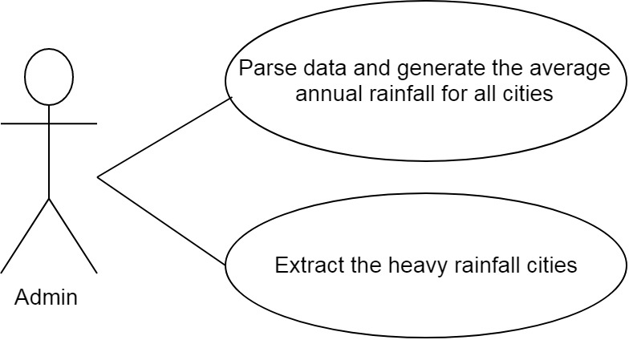

## System Architecture Diagram

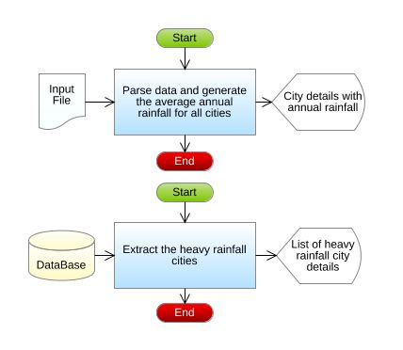

# Design Specification

## Data Design

**Table Structure:**

|  |  |
| --- | --- |
| Table name: AnnualRainfall | |
| Column Name | **Data type** |
| city_pincode | number |
| city_name | varchar |
| average_annual_rainfall | double |

**Design Constraints:**

* Use MYSQL database to store the data. The database name should be “RainfallReport”.
* The above table has been already created. To create the table in your local machine, the script is available in “script.sql”, which will be provided as part of the code skeleton.
* The table names and the column names should be the same as specified in the table structure.
* Database connections should be configurable; it should not be hard coded. The database information is specified in the “db.properties” file, which is also provided as part of the code skeleton.

**Note:** The code skeleton is available in the Tekstac platform

## Component Design for identified Use cases



### Parse data and generate the average annual rainfall for all cities

The average monthly rainfall in each city and the other details of the city are stored in a flat file. Retrieve the data from the file and calculate the average annual rainfall of each city based on its monthly rainfall. The details of the cities with the rainfall details are stored in a file named AllCityMonthlyRainfall.txt.

Sample File containing rainfall details. The file is comma delimited.

[AllCityMonthlyRainfallFormat: cityPincode,cityName,JanRainfall,FebRainfall,MarRainfall,AprRainfall,MayRainfall,JunRainfall,JulRainfall,AugRainfall,SepRainfall,OctRainfall,NovRainfall,DecRainfall]

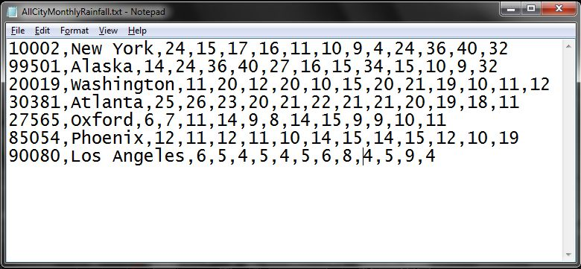

From the AllCityMonthlyRainfall.txt file, read the details, parse the data and construct an AnnualRainfall object for each record in the file, then calculate the averageAnnualRainfall of each city based on the conditions mentioned below:

Average Annual Rainfall = (sum of all monthly rainfall of a city)/number of months

**For example:** If the city has a monthly rainfall as

30, 15.5, 12, 10, 15, 20.9, 21, 22, 20, 18.6, 15, 10

then the averageAnnualRainfall will be

(30+15.5+12+10+15+20.9+21+22+20+18.6+15+10)/12, which is 210/12 = 17.5

Therefore, the averageAnnualRainfall of that city is 17.5

After calculating the averageAnnualRainfall, store all the AnnualRainfall object into a list.

**Validation:**

The city Pincode should contain exactly 5 digits. If the city Pincode is valid then parse the data and calculate the average annual rainfall else throw a user defined Exception “InvalidCityPincodeException” with a message "Invalid City Pincode".

**Component Specification: AnnualRainfall(model class)**

|  |  |  |  |  |
| --- | --- | --- | --- | --- |
| **Component Name** | **Type(Class)** | **Attributes** | **Methods** | **Responsibilities** |
| Parse data and calculate the average annual rainfall of all cities | AnnualRainfall | int cityPincode  String cityName  double averageAnnualRainfall | Include getters and setter method for all the attributes. |  |
| Parse data and calculate the average annual rainfall of all cities | AnnualRainfall |  | void calculateAverageAnnualRainfall (double monthlyRainfall [ ] ) | This method should calculate and set the averageAnnualRainfall based on the monthly rainfall the city received |

**RainfallReport(utility class)**

|  |  |  |  |  |
| --- | --- | --- | --- | --- |
| **Component Name** | **Type(Class)** | **Method** | **Responsibilities** | **Exception** |
| Parse data and calculate the average annual rainfall of all cities | RainfallReport | List<AnnualRainfall>generateRainfallReport(String filePath) | This method takes the file path as argument and it should parse the data stored in the file and it should validate the city Pin code by invoking the validate() method, if valid, construct an AnnualRainfall object for each record in the file, then calculate the average annual rainfall by invoking the calculateAverageAnnualRainfall(double monthlyRainfall []) method of AnnualRainfall class. After calculating the averageAnnualRainfall, each AnnualRainfall should be added into the list and this method should return the list of AnnualRainfall. |  |
| Parse data and calculate the average annual rainfall of all cities | RainfallReport | boolean validate(String cityPincode) | This method should validate the city pincode, if valid return true else this method should throw an userdefined exception | Throw a user defined exception “Invalid CityPincode Exception” if the pincode is invalid. |

**Note:** The data file will contain both valid and invalid details. Valid rainfall details should be added to the list and for the invalid ones, user defined exception should be thrown.

### Extract the names of the cities with heavy rainfall

The averageAnnualRainfall of each city is stored in the database, the meteorological department will find the maximumRainfall value and display the city details which received the maximumRainfall from the database.

**Component Specification:**

**RainfallReport(utility class)**

|  |  |  |  |  |
| --- | --- | --- | --- | --- |
| **Component Name** | **Type(Class)** | **Method** | **Responsibilities** | **Resources** |
| Extract the names of the cities with heavy rainfall | RainfallReport | List<AnnualRainfall> findMaximumRainfallCities () | This method should extract all the AnnualRainfall details from the AnnualRainfall table and return the list of cities with maximum averageAnnualRainfall.  Connect to the database by invoking the establishConnection() method of DBHandler class. | MYSQL database is used. Retrieve the details from AnnualRainfall table |

**DBHandler(DAO class)**

|  |  |  |  |  |
| --- | --- | --- | --- | --- |
| **Component Name** | **Type(Class)** | **Method** | **Responsibilities** | **Resourc****es** |
| Extract the names of the cities with heavy rainfall | DBHandler | Connection establishConnection() | This method should connect to the database by reading the database details from the db.properties file and it should return the connection object | MYSQL database is used. Store and retrieve the details into/from AnnualRainfall table.  db.properties file is used for storing the database details. |

## General Design Constraints

* 1. The attribute/method/class name should be correctly specified as given in the document.
  2. Do not hardcode the database configuration details in the DBHandler class, read it from the db.properties file.

# Submission

## Code submission instructions

Do not change the code skeleton given, as your code will be auto evaluated.

You can validate your solution against sample test cases during the assessment duration.

Your last submitted solution will be considered for detailed evaluation.

Make sure to submit the solution before the specified time limit. You will not be allowed to submit the solution once the mentioned time for the assessment is over.

# Change Log

|  |  |  |  |  |
| --- | --- | --- | --- | --- |
|  | Changes Made | | | |
| V1.0.0 | Initial baseline created on <dd-Mon-yy> by <Name of Author> | | | |
| Vx.y.z | <Please refer to the configuration control tool / change item status form if the details of changes are maintained separately. If not, the template given below needs to be followed> | | | |
| **Section No.** | **Changed By** | **Effective Date** | **Changes Effected** |
|  |  |  |  |